Abdullah Ghani 19F-0909

Zain Ul Abideen 19F-0915

Mahnoor 19F-0965

**SE-4A**

Grasp pattern

Project name:

Rent A Ride- Bus/Car riding and car booking system.

# Group member:

Abdullah Ghani 19F-0909

Zain Ul Abideen 19F-0915

Mahnoor 19F-0965

# Section:

SE-4A

# Grasp pattern

Class diagram:

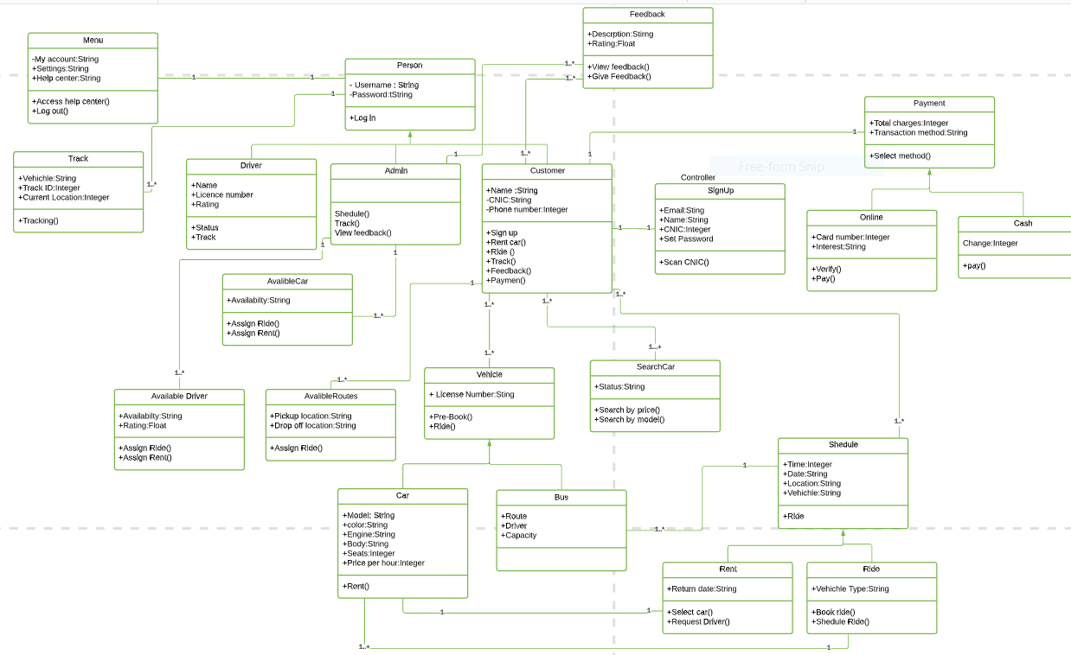

Sequence diagram:

